 | Squirrel Away Activity | 

Code your robot squirrel to collect an acorn.
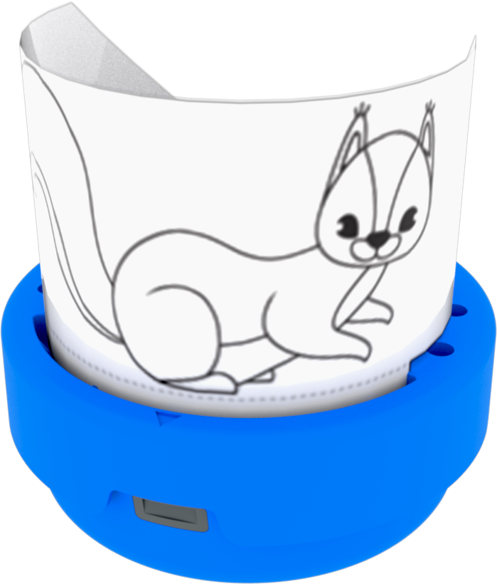 | Make a squirrel on the . Put it on your 123 Robot.
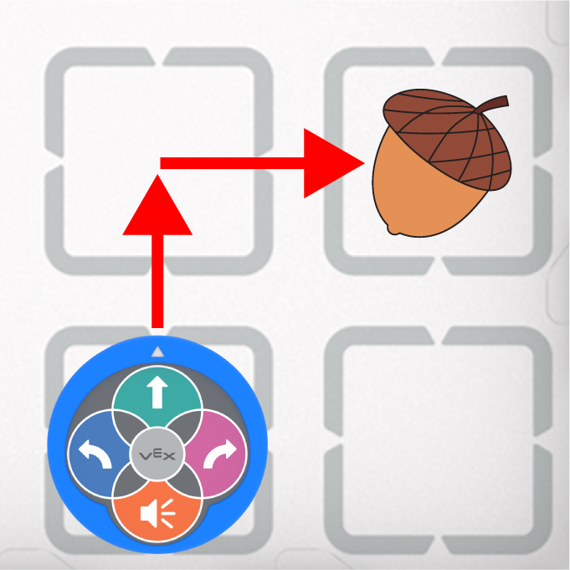 | Code your squirrel to drive from the start to an acorn.
 | Press the Start button to test your project.
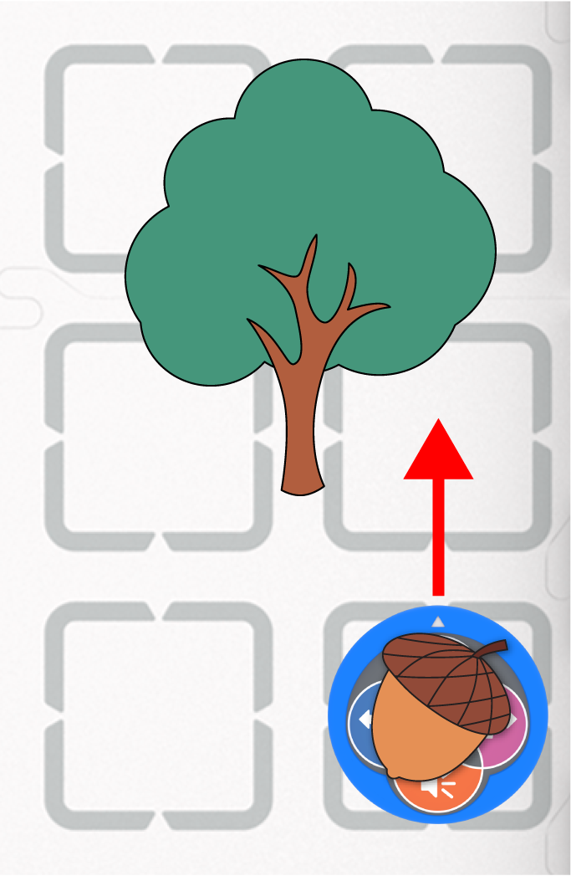 | Put the acorn on your robot to collect it.  Code your robot to take the acorn to the tree!
How many more acorns can your robot squirrel collect?
Shake to erase your project and collect as many as you can!

Using the 123 Robot
 | Push the 123 Robot to wake it up | 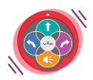 | Shake the robot to erase a project
 | Drives the 123 Robot 1 step |  | Turns the 123 Robot to the left
 | Plays a honk sound |  | Turns the 123 Robot to the right

Squirrel Away
Activity Notes

Hands-on time for this activity is approximately 1 hour.

Preparing for the Activity

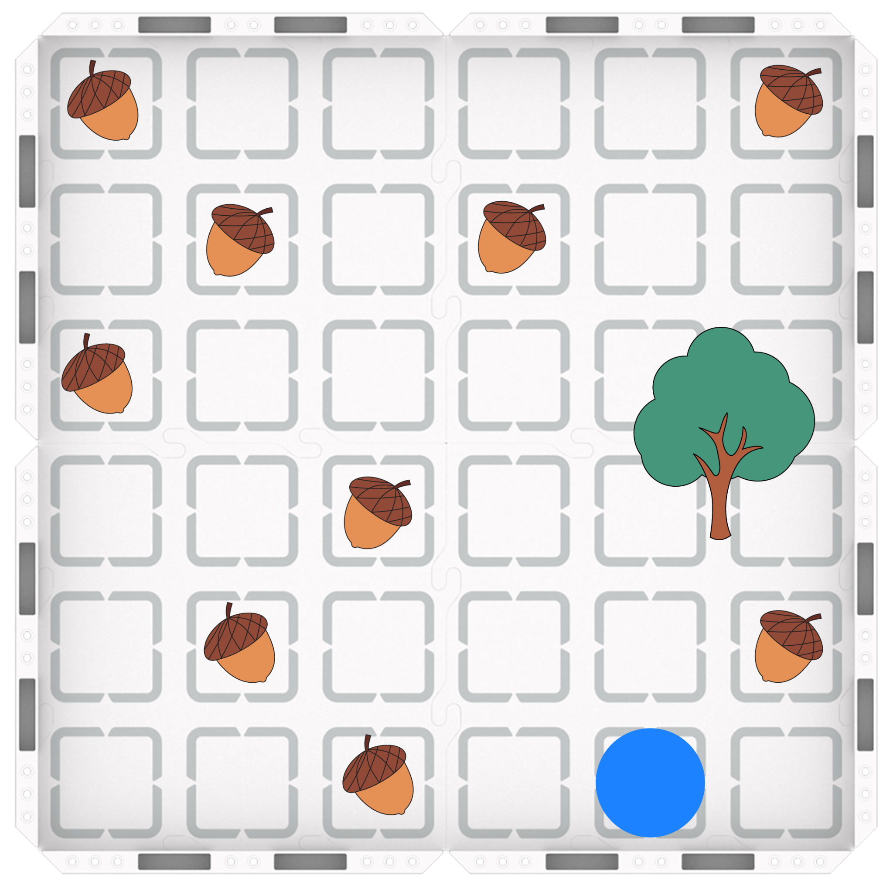
No additional materials are needed for this activity beyond those listed in the Instructor Notes for VEX 123 Activities.

Set up the field as shown.
- Print and cut the acorns and tree.
- Tape the tree onto your Field.
- Scatter starting locations for the acorns around the Field, marking each with tape or a wet erase marker.
  - Acorns will move during the activity. This allows students to reposition them as needed.
- Mark the starting square(s) with tape or a wet erase marker (shown with the blue circle to the right).

Facilitating Squirrel Away

- Introduce the activity. Share the story here with students, and show students the Field setup. You may want to have an example squirrel premade to act out the story on the Field.
 | The weather was changing, and the squirrels in the forest could feel that winter was on its way. The leaves were changing colors, and some were starting to fall. One night, big winds blew through the forest, blowing a lot of leaves and acorns out of the trees. When the squirrels woke up the next morning, they were excited to see all the food on the forest floor! The wise squirrel reminded the younger squirrels that they could have some acorns now, but should collect as many as they could to start their store for winter. The squirrels spent the day running around the forest floor, looking for and collecting acorns, then bringing them to the tree where they had made their home. By the end of the day they were amazed at how many acorns they had already gathered for winter, and were rewarded for their teamwork with a delicious acorn dinner and the supplies for plenty more to come!
- Brainstorm and Craft: Share how students can use the provided craft materials and/or the printed squirrel and the Art Ring to turn their 123 Robot into a squirrel, and allow time to do so.
  - Be sure that the center of the Art Ring is clear enough to enable students to easily press the Touch buttons while the squirrel is attached.
  - As students complete their Art Rings, show them how to attach the Art Ring to the 123 Robot.

- Demonstrate the Activity:
  - Ensure students know how to use the 123 Robot (push to wake, pressing buttons to code, and shaking to erase).
  - Show students where the robot should start on the Field. The robot can start facing any direction.
  - Brainstorm with students how to plan and code a project to make the robot drive to the first acorn. Code and start this project for students to see.
    - You can use the example here to move, turn, and move again to collect the nearest acorn.
    - Once you reach the acorn, pick it up. (Students can put it on their squirrel, or manually move it to the tree.)

- Direct students to start the Squirrel Away activity.
  - Move around the room and talk with students, asking questions like:
    - Did your robot reach its first acorn? How did you code your robot to get there?
    - Did it work the first time? If not, what did you do differently the second time?
  - Students can drive to any of the four squares around the tree to store their acorn. They can place the acorn on the tree, or remove it from the Field to show the acorn was stored.
  - Students should take turns coding the robot. One student can code the project to drive to the acorn, and the partner can code the project to drive from the acorn to the tree.
  - Once students have collected and stored one acorn, have them erase their project, put the robot back at the start, and begin again to collect another acorn.

To extend the activity, complete it with the Coder and Coder cards. See Using the VEX Coder for more information.

